Automatic Rollback in GitHub Actions

If deployment fails, automatically restore the previous working version instead of leaving the application in a broken state.

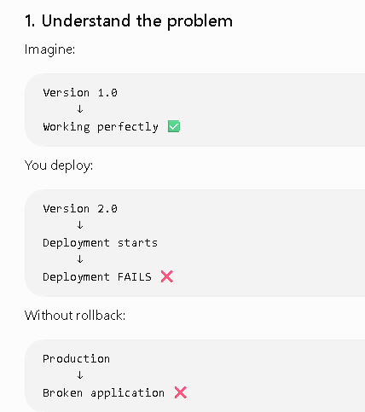
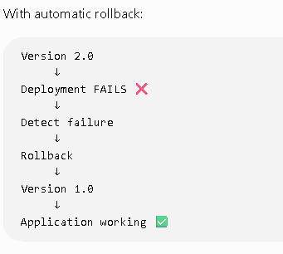
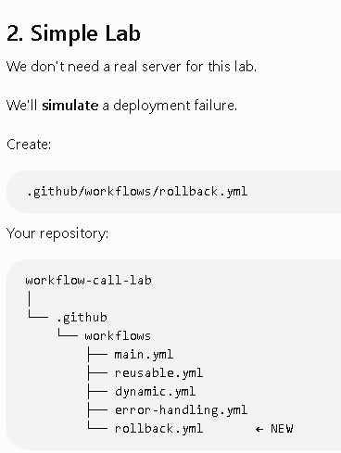
3. Create rollback.yml
Put this:
name: Automatic Rollback Demo
on:
push:
jobs:
deploy:
runs-on: ubuntu-latest
steps:
- name: Deploy Application
id: deployment
run: |
echo "Deploying version 2.0..."
echo "Deployment started..."
echo "Deployment failed!"
exit 1
- name: Automatic Rollback
if: failure()
run: |
echo "Deployment failed!"
echo "Starting automatic rollback..."
echo "Restoring version 1.0..."
echo "Rollback completed successfully!"
- name: Cleanup
if: always()
run: echo "Cleaning deployment resources..."

4. What happens?
When you push the file:
Deploy Application
↓
Deploying version 2.0
↓
❌ Deployment failed
↓
Automatic Rollback
↓
Restoring version 1.0
↓
✅ Rollback completed
↓
Cleanup
The important part is:
if: failure()
It tells GitHub:
If something before this step failed, execute the rollback step.
The document uses the same pattern:
- name: Execute Rollback
if: failure()
and then runs the rollback script.
5. Why do we use id?
The document also demonstrates giving the deployment step an ID:
- name: Risky Production Deployment
id: deploy_step
run: ./deploy.sh
Then rollback can specifically check:
if: failure() && steps.deploy_step.outcome == 'failure'
For example:
- name: Automatic Rollback
if: failure() && steps.deployment.outcome == 'failure'
run: |
echo "Rolling back..."
echo "Restoring previous version..."
This means:
Did deployment fail?
↓
YES
↓
Run rollback

Complete Self-Healing Flow

